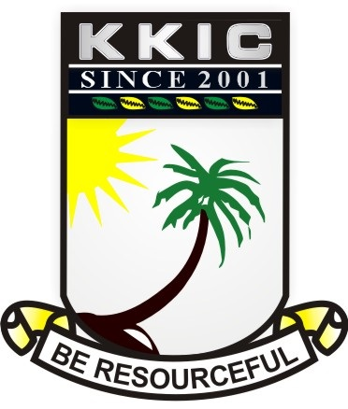

|  |  |  |  |  |  |  |
| --- | --- | --- | --- | --- | --- | --- |
| **SURNAME** |  | | **OTHER SURNAMES** |  | | |
| **SUBJECT** | **CIVIC EDUCATION** | **CLASS** | | **JSS1** | **DURATION** | **1HOUR, 30 MINS.** |

***INSTRUCTION: ANSWER ALL QUESTIONS FROM THIS SECTION***

***SECTION A-OBJECTIVE* [20 MARKS**

1. The state of being aware and responsive to one’s surroundings is ---------
2. consciousness
3. alive
4. sleeping
5. playing
6. ----------- is the feeling of love, devotion and attachment to one’s country
7. Citizenship
8. Patriotism
9. Alien
10. Nationality
11. A mark or character used to represent an object or a function is referred to as ------
12. characters
13. language
14. symbols
15. pointers
16. An example of the national symbol is ----------
17. Traffic light
18. Zebra crossing
19. Pedestrian
20. Coat of arm
21. The armorial bearing is also known as the
22. coat of many colours
23. power house
24. command
25. coat of arm
26. From the image below which of these cannot be found on the coat of

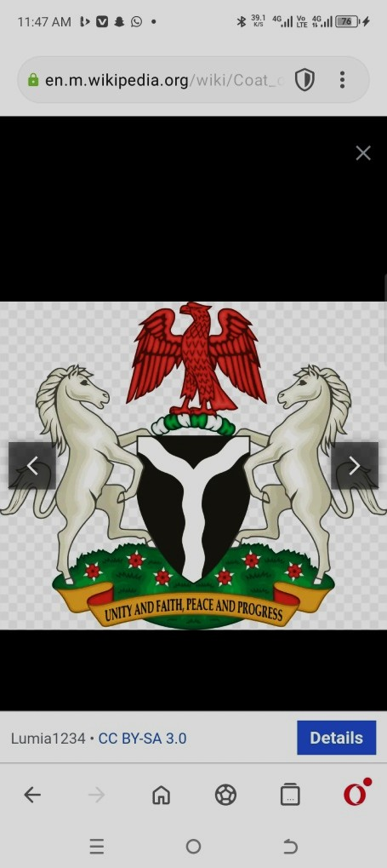

1. horse
2. eagle
3. parrot
4. black shield
5. The motto on the coat of arm is unity and faith, peace and -----------
6. power
7. progress
8. people
9. pieces
10. The fertile land of the country is represented by the ----------
11. black shield
12. Y-shaped
13. two horses
14. flowering plant
15. The two horses on the image below represent ---------------
16. peace and power
17. unity and peace
18. integrity and dignity
19. fertile soil
20. The point where the two rivers meet is called ------------
21. meeting point
22. joining point
23. confluence
24. center
25. The flowering plant is also known as ----------------
26. roses
27. coctus spectabilis
28. hibiscus
29. yarn
30. The Y-shaped silvery band represent river Niger and river -----------
31. Nile
32. Benue
33. Lokoja
34. Akwa-ibom
35. The confluence is located at ----------
36. Niger
37. Minna
38. Lokoja
39. Abia
40. The eagle depicts ----------
41. integrity
42. unity
43. peace
44. pride
45. Which of these is **not** among the national symbols?
46. The national anthem
47. The coat of arms
48. The national flag
49. The Nigerian army
50. The Nierian flag was designed by ------ in the year -----------
51. Mike Taison, 1978
52. Mike Tyson, 1959
53. Michael Taiwo Akunyemi, 1959
54. Michael Taiwo Akinkunmi 1959
55. The Nigerian flag was hoisted on ---------
56. October 1st, 1960
57. October 1st, 1959
58. October 1st. 1963
59. January 1st, 1961
60. The colour green on the national flag stands for agriculture while the colour white stands for peace and ----------
61. Progress
62. Justice
63. Unity
64. Power
65. The old Nigeria anthem was composed by -------------
66. Lillian Barch
67. Benedict Odinaka
68. Tim Godfrey
69. Benedict Elise Odiase
70. Arise O’ compatriot was adopted in the year -------------
71. 1975
72. 1976
73. 1977
74. 1978
75. The first Nigeria anthem was written by --------------
76. Lillian Jean Williams
77. Anikulapo Fela Ransomkuti
78. Sir Shina Peter
79. African China
80. The old Nigeria anthem has ------- stanza while the new one has -------- stanzas
81. 3 and 4
82. 2 and 3
83. 23 and 2
84. 2 and 4
85. Nigeria may be blessed is last line in the ------------ stanza
86. first
87. second
88. third
89. fourth
90. A statement of oath by the citizens to the Nigerian state is the -----------
91. school anthem
92. church pledge
93. school pledge
94. national pledge

1. The national pledge was written by ---------- in the year -----------
2. Felicia Adebola Adedoyin, 1976
3. Felicia Natasha, 1976
4. Patience Jonathan, 1975
5. Stella Obasanjo, 1976
6. The image below shows a team reciting the ---------

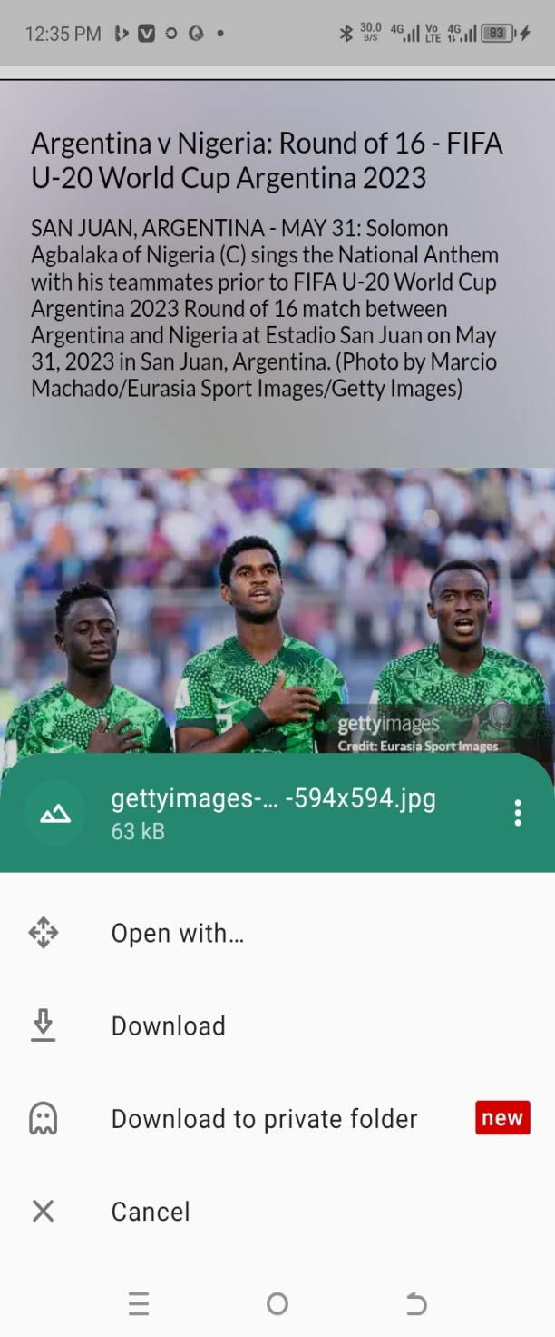

1. national pledge
2. national song
3. school song
4. church song
5. The official medium of exchange in Nigeria is ----------
6. pound
7. dollars
8. yen
9. naira and kobo
10. The highest currency in Nigeria is --------
11. #100
12. #200
13. #500
14. #1000
15. Whose images are on the #1000 note?
16. Dr. Nnamdi Azikiwe and Sir Ahmadu Bello
17. Alhaji Aliyu Mai- Bornu and Clement Isong
18. Sir Tafawa Balewa and Alvan Ikoku
19. Bola Tinubu Ahmed and Babajide Olusola Sanwolu
20. Dr. Nnamdi Azikiwe is on the ---------- naira note
21. #100
22. #200
23. #500
24. #1000
25. Which of **these** is also known as international passport?
26. The national identity card
27. Voter’s card
28. Tax ID
29. The national passport
30. All these are information on the national identity card **EXCEPT** -----------
31. date of birth
32. passport photograph
33. residential address
34. complexion
35. The image below shows ---------



1. a corp member
2. a navy
3. a police
4. an army
5. Which of **these** is not an establishment to promote national unity?
6. Unity schools
7. National festivals
8. Nigerian Defense Academy
9. Airports
10. NYSC was established in the year ------------
11. 1971
12. 1972
13. 1973
14. 1974
15. The full meaning of NYSC is -------------
16. National Youth Service Corps
17. Nigerian Youth Service Call
18. Now Your Suffering Continues
19. Nigeria Young Servants Corps
20. All these are the purpose of the NYSC scheme **EXCEPT**
21. To develop common ties among youths
22. To promote indiscipline among youths
23. To remove prejudice and ignorant
24. To enable youths acquire the support of self-reliance
25. One of **these** is a unity school
26. Kith & kin International school
27. Caleb International school
28. Federal Government College
29. Fountain Height school
30. All **these** are national festivals EXCEPT
31. National sport festivals
32. Cultural and Art fesytivals
33. Exhibition and Science Technology
34. Olympic games
35. One other way of promoting national unity is -----------
36. non-discrimination of tribe
37. getting a national identity card
38. getting an international passport
39. going to unity school
40. One of these is **no**t a way of promoting national unity
41. Encouragement of inter-marriage
42. Hospitality
43. Tolerance
44. Fighting
45. The above picture is known as the --------

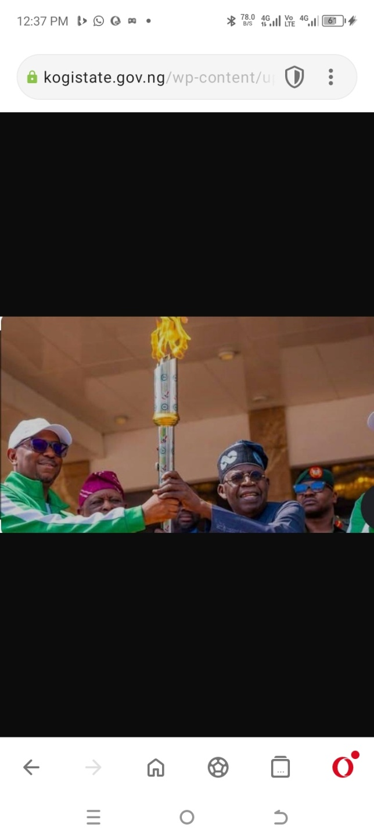

1. Lamp
2. Torch
3. Mace
4. Unity lamp
5. A document that contains the rules and regulation that governs a country is known as the ----------
6. handbook
7. notepad
8. map
9. constitution
10. Values include all **EXCEPT**
11. hardwork
12. discipline
13. laziness
14. integrity
15. All these are sources of values **EXCEPT**
16. food
17. family
18. community
19. religious institution
20. ---------- is the ability to do things by oneself without relying on other people
21. honesty
22. self-discipline
23. self-reliant
24. self-affection
25. One of **these** is an attribute of self-reliance
26. It promotes independence
27. It does not help in development
28. It does not promote self-confidence
29. It does not help one to discover one’s talent
30. ------- are obligations of citizens in a country
31. Responses
32. Duties
33. Rights
34. Associations
35. ------ are claims of individuals as a citizen of a country
36. Duties
37. Responsibilities
38. Rights
39. Taxes
40. Non-performance of citizens’ obligations can result to all **EXCEPT**
41. chaos
42. confusion
43. violence
44. peace

**SECTION B: THEORY**

**INSTRUCTION: ANSWER FOUR QUESTIONS IN ALL IN THIS SECTION**

1. Define national symbol **2marks**

1b. List eight national symbols 8marks

1. Mention five objects on the coat of arm and what each symbolizes 5marks

2b. List five information contained on the national identity card 5marks

1. Write the first stanza of the national anthem 5marks

3b. In a tabular form write the names of the Nigerian heroes on the following naira note

(i) #200 (ii) #100 (iii) #10 (iv) #20 (v) #50 5marks

1. List four institution established by the government to promote national unity 4marks

4b. state three ways individuals can promote national unity 3marks

4c. Write the national pledge 3marks

1. Define the following (i) honesty ii. dishonesty 2marks

5b. write four benefits of honesty and four punishments for dishonesty 8marks

1. State three differences between a citizen and a non-citizen 3marks

6b. write three rights of a citizen and four duties of a citizen 7marks